STUVA Press Release 1/2026

Research and development work by STUVA
From excavated material to construction material: research project investigates how soil and rock can become a sustainable cement substitute

Cologne, July 2026. Each year, tunnel construction and civil engineering projects generate millions of tonnes of excavated material, which to date has usually been disposed of unused in landfill sites. In the “Geo-BAB” research project, an interdisciplinary consortium is investigating how such clay-mineral-bearing material can be utilised as a low-CO2 alternative to conventional cement through thermal treatment and chemical activation.

In Germany alone, according to STUVA statistics, tunnel construction projects produce more than four million tonnes of excavated material each year. While hard rock can be used, for example, as aggregate in concrete, the utilisation of cohesive soils such as silts and clays is considerably more difficult. To develop a sustainable solution for these materials as well, the research project is based on the process of calcination. In this process, clay-bearing material is dried, ground and heated in a kiln. This thermal treatment changes the structure of the clay minerals, making them reactive and therefore capable of binding.
The consortium, comprising the two research institutions STUVA e. V. and TH Köln as well as the three practice partners IMM Maidl & Maidl Beratende Ingenieure GmbH & Co. KG, Brameshuber + Uebachs Ingenieure GmbH and MC-Bauchemie Müller GmbH & Co. KG, brings together expertise in construction materials technology, mineralogy, geotechnics, chemistry and civil engineering.

Two routes to climate-friendly binders
To exploit the potential of these calcined clays, the partners are pursuing two technological approaches: in clinker-reduced systems, the treated material is intended to replace part of the conventional cement clinker. Of particular interest here is the proportion that can be replaced by calcined clay without compromising quality. Since, according to the German Environment Agency, cement production is responsible for around eight per cent of global greenhouse gas emissions, this substitution approach significantly reduces the CO2 footprint of concrete.
At the same time, the consortium is also investigating entirely cement-free binders. In these systems, strength development is initiated by so-called activators such as the mineral compound water glass. The result is an alternative binder that represents a particularly resource-conserving option for the construction industry.

From laboratory sample to mobile calciner
In the “Geo-BAB” project, various unconsolidated and hard rocks from Germany’s low mountain ranges, metropolitan regions and international major construction sites are being investigated.
First, the material is characterised and its strength development is tested in the laboratory. The project is also examining how practical implementation can be achieved. For this purpose, a mobile calciner is to be used on site, so that the material can be processed directly on the construction site at a technically relevant scale.
The possible applications for the new binders made from tunnel excavated material are diverse. They include tunnel construction itself, for example in annular gap filling materials between the tunnel lining and the ground. Concrete paving blocks for gardening and landscaping as well as ballast concrete for hydraulic engineering are further potential fields of application.

About the project
The joint project “Geo-BAB” (Calcination of geogenic secondary raw materials from tunnel construction for the production of alternative binders) is being funded over a period of two years by the Federal Highway Research Institute (BASt) with around 650,000 euros under the “Innovation Programme Road”.
((Text: 3,700 characters incl. spaces/2 images))

Download the text as Word and PDF files and the images from www.stuva.de

Captions:

Image 1: Visualisation of a calciner as it could be used in the project. Copyright: (AI-generated symbolic image)

Image 2: Calcined clays, natural sand, cement and water, as investigated in the predecessor project. Copyright: (Image: Benedict Bremert / TH Köln)

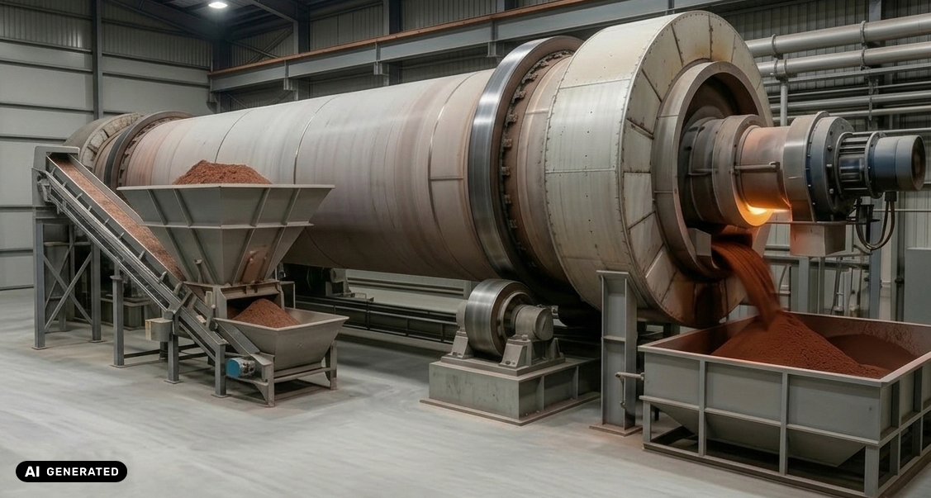
Image 1

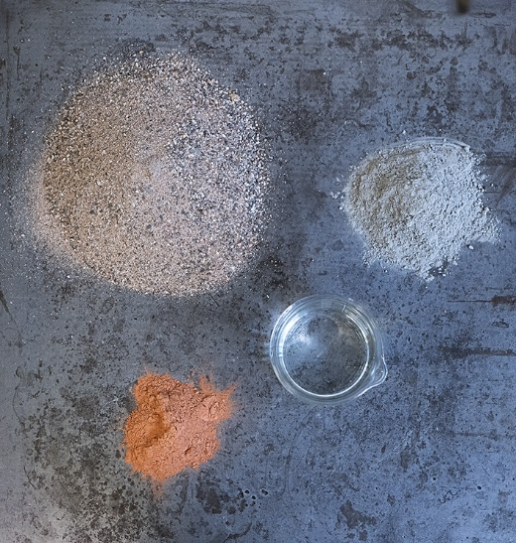
Image 2

Your contacts:

STUVA e. V. und STUVAtec GmbH
Managing Director
Dr.-Ing. Roland Leucker
E-Mail: r.leucker@stuva.de

Geo-BAB Project Coordinator
Dr.-Ing. Christian Thienert
E-Mail: c.thienert@stuva.de
Tel.: +49 (221) 5 97 95-0
www.stuva.de

